*PROJECT REPORT TEMPLATE*

1. INTODUCTION

* 1. OVERVIEW

In our project we use custom objects, relationships, page layouts to give the HR team easy access to data they need on an existing recruiting app.

* 1. purpose

The recruitment function of HR incudes analyzing the recruitment of an available job, attracting suitable candidates to the position, carefully screening and selecting all applicants, hiring, and seamlessly integrating new employees and roles into the organization.

1. Problem definition & design thinking

2.1 empathy map

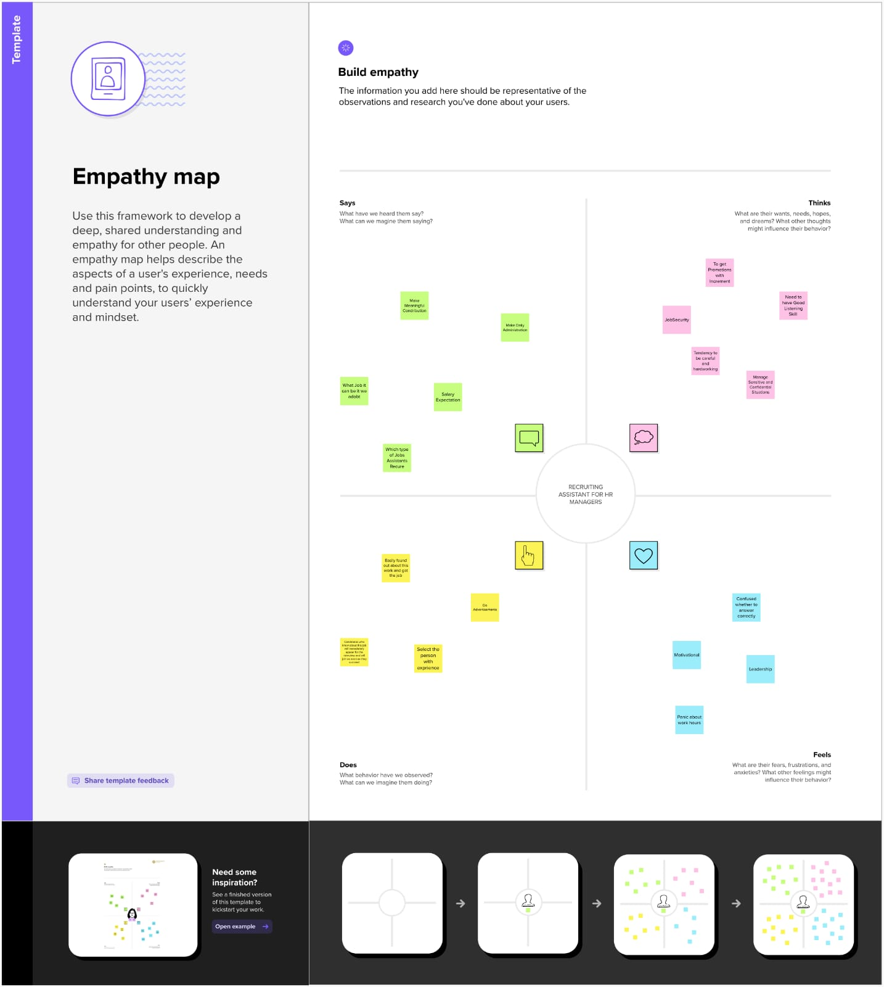

2.2 ideation & brainstorming map

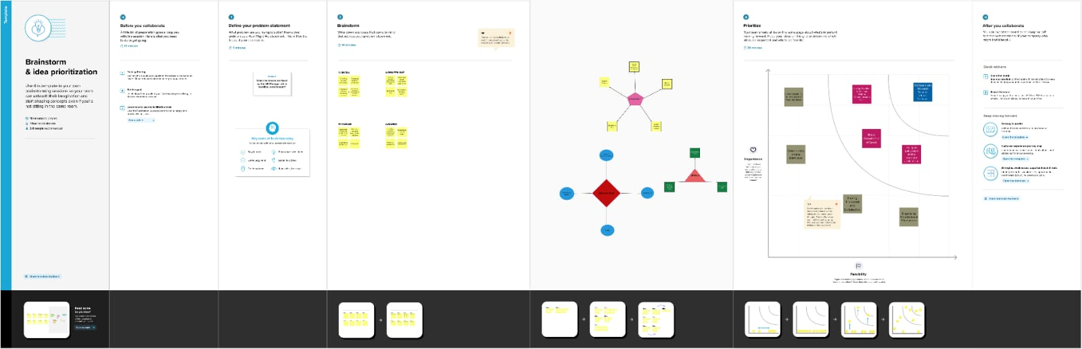

1. Result
   1. data model:

|  |  |
| --- | --- |
| Object name | Fields in the object |
| Job posting site | |  |  | | --- | --- | | Field label | Data type | | Job posting site URL | URL(255) | | Job posting site name | Text(80) | |
| position | |  |  | | --- | --- | | Field label | Data type | | Position name | Text(18) | | Position number | Auto number | |

* 1. activity & screenshot

Milestone-1

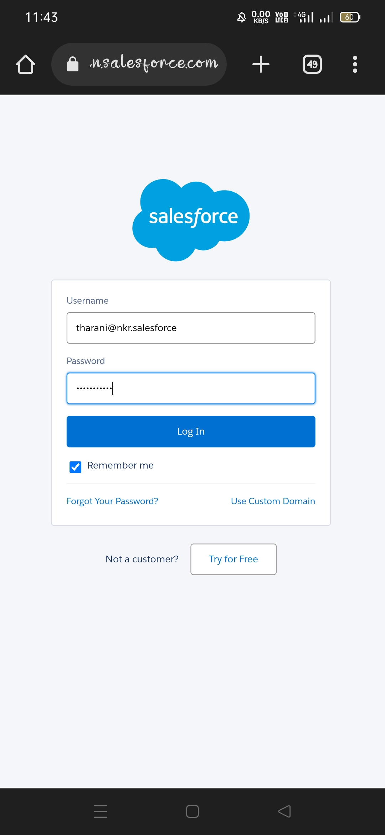

**We created a developer org through the website by entering the details such as our first name, last name, email, role, company and username.**

Milestone-2

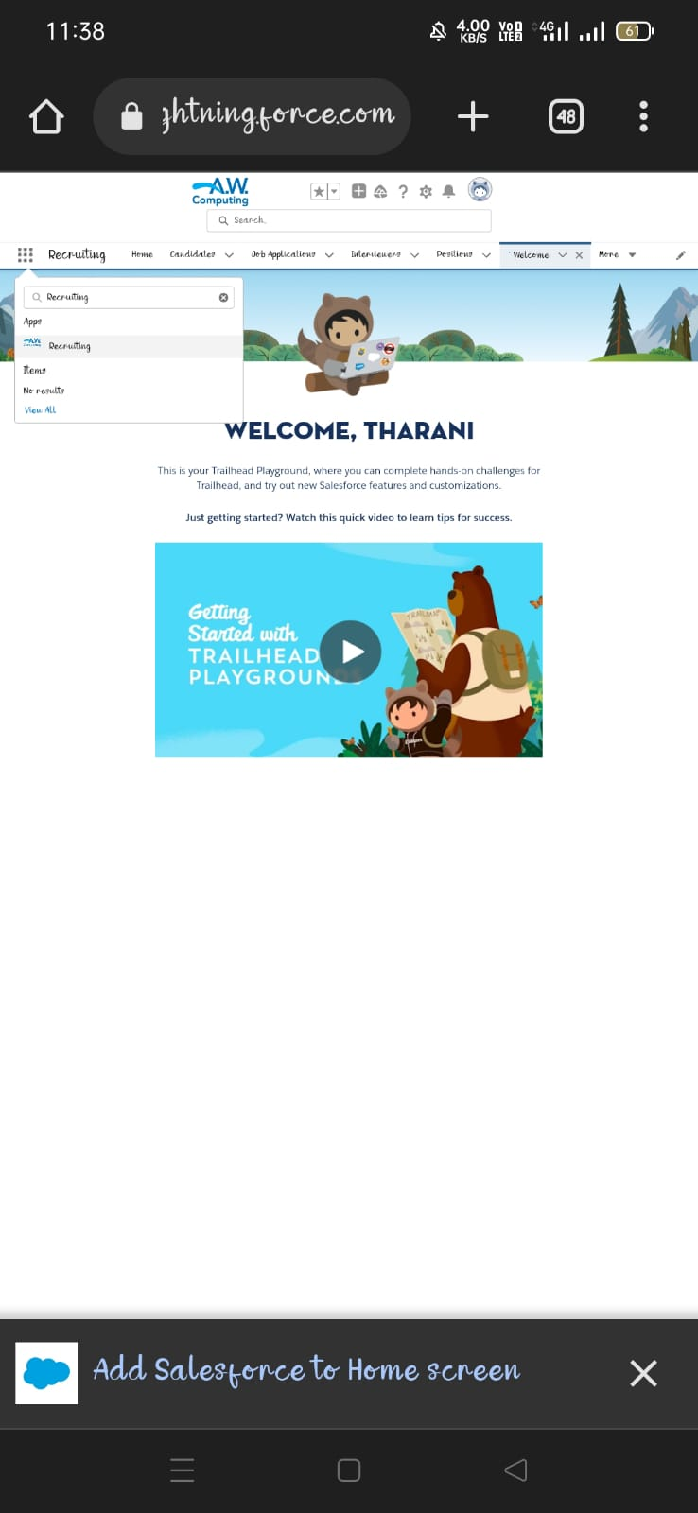

We downloaded the recruiting app from the “app launcher”

Milestone-3

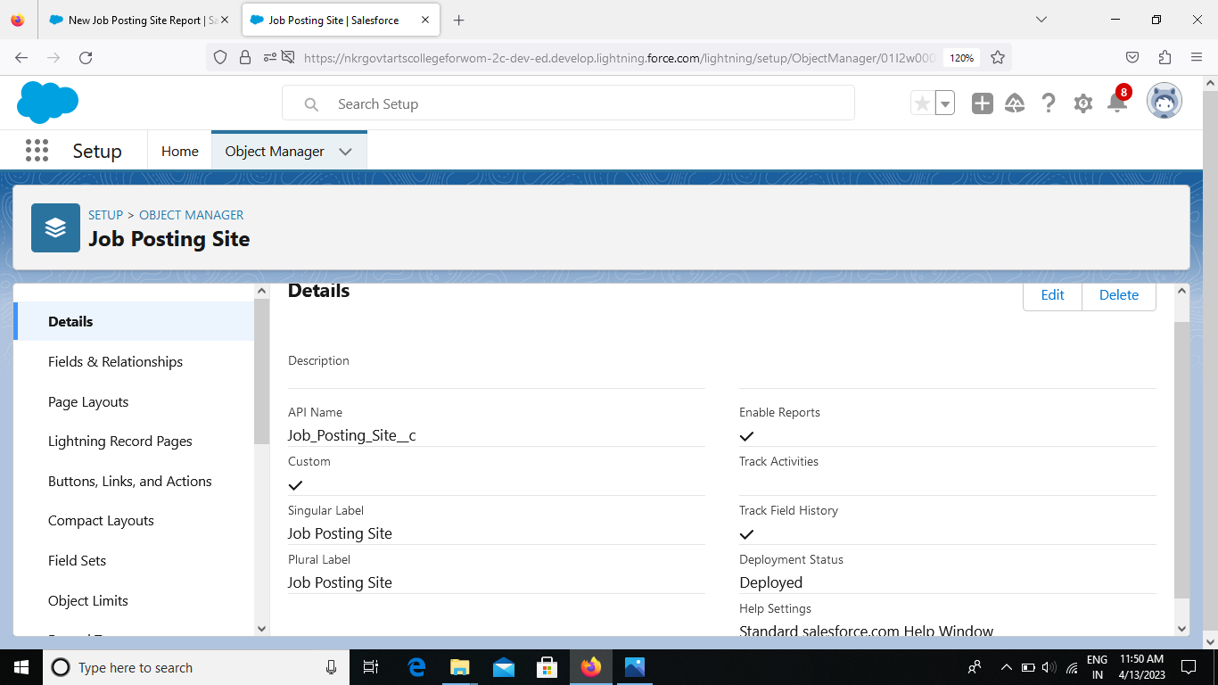

We created the custom object for job posting sites by typing the label as “job posting site”.

Milestone-4

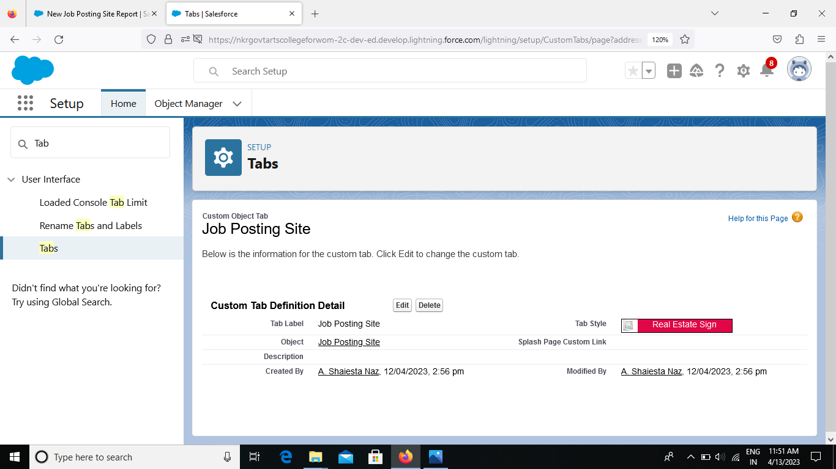

We created a custom object tab for “job posting site”.

Milestone-5

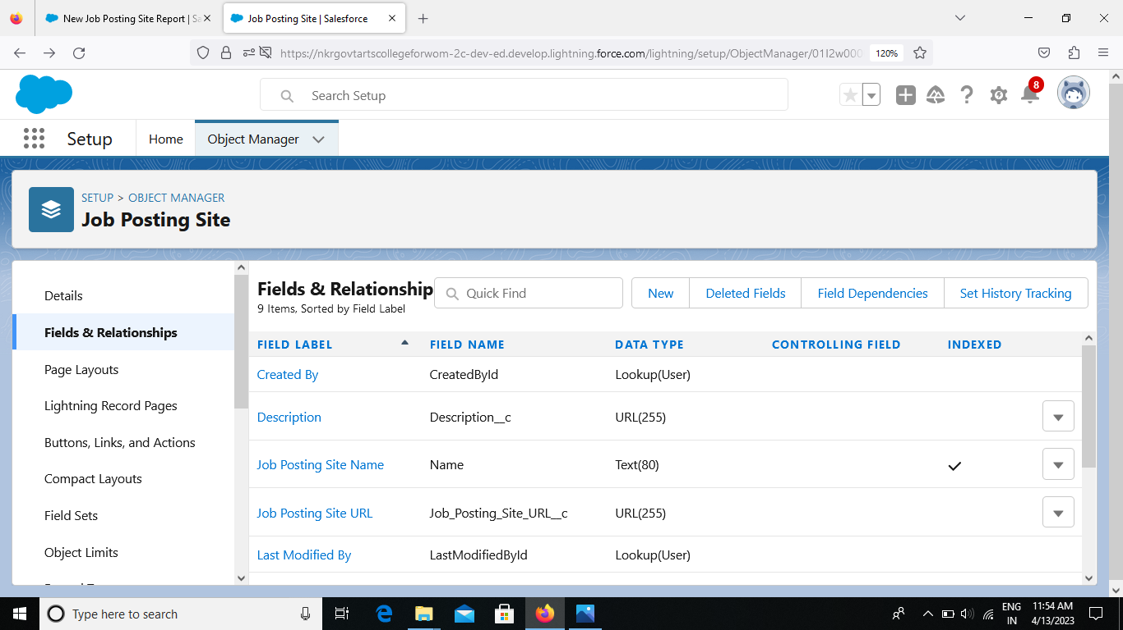

We created a new field for “job posting site”.

Milestone-6

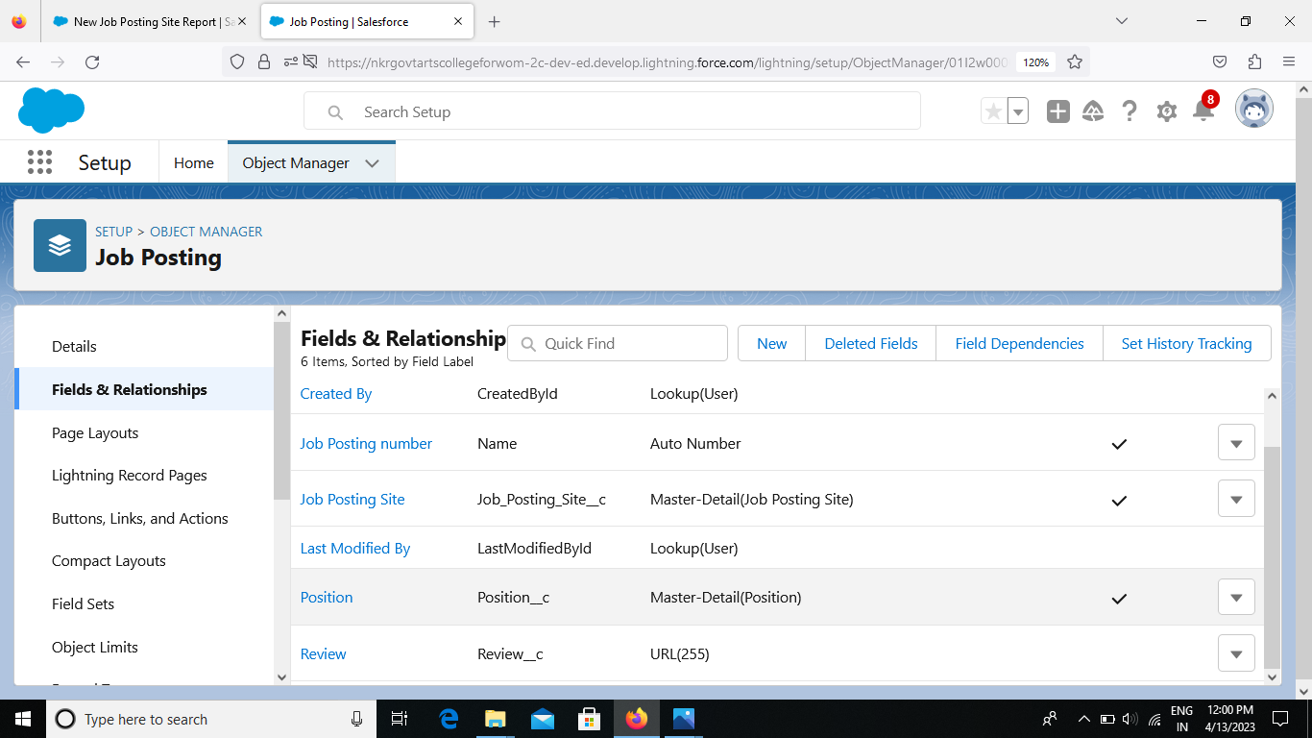

We created a junction object and created a master-detail relationship between “job posting and position”.

Milestone-7

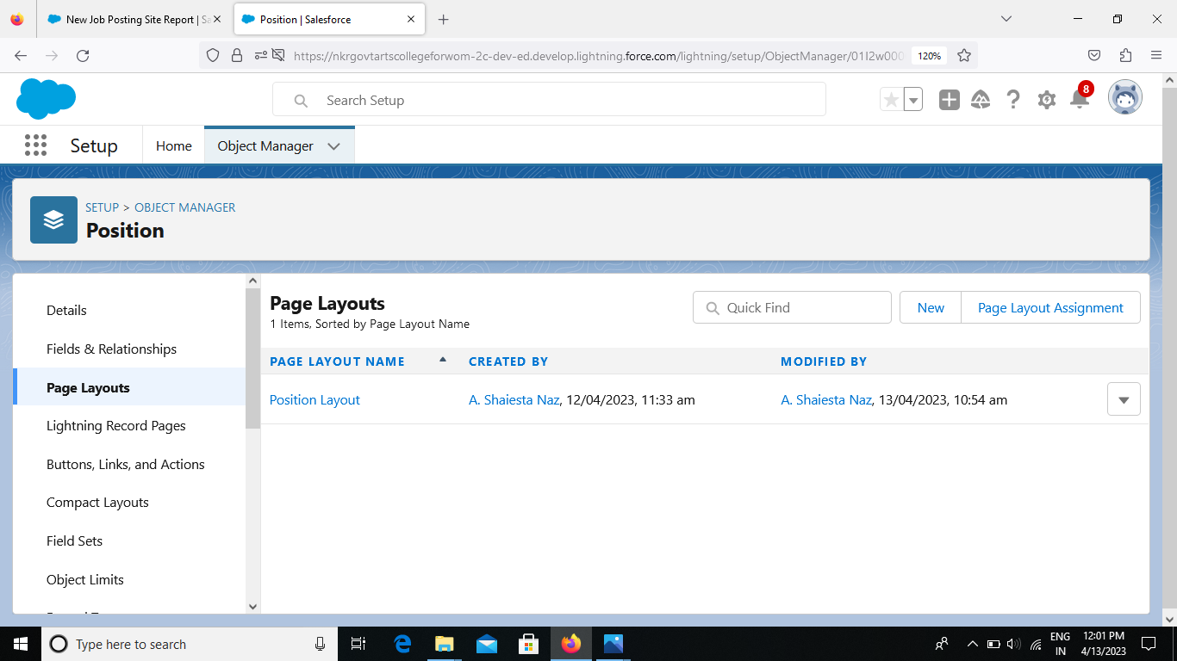

We created a page layout for “position object”.

Milestone-8

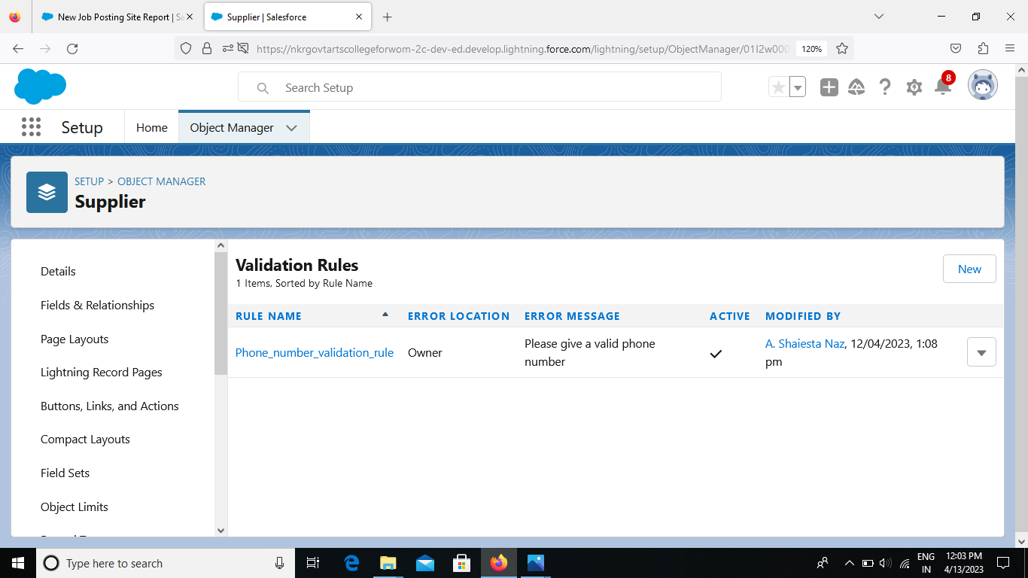

We created a validation rule for “supplier”.

Milestone-9

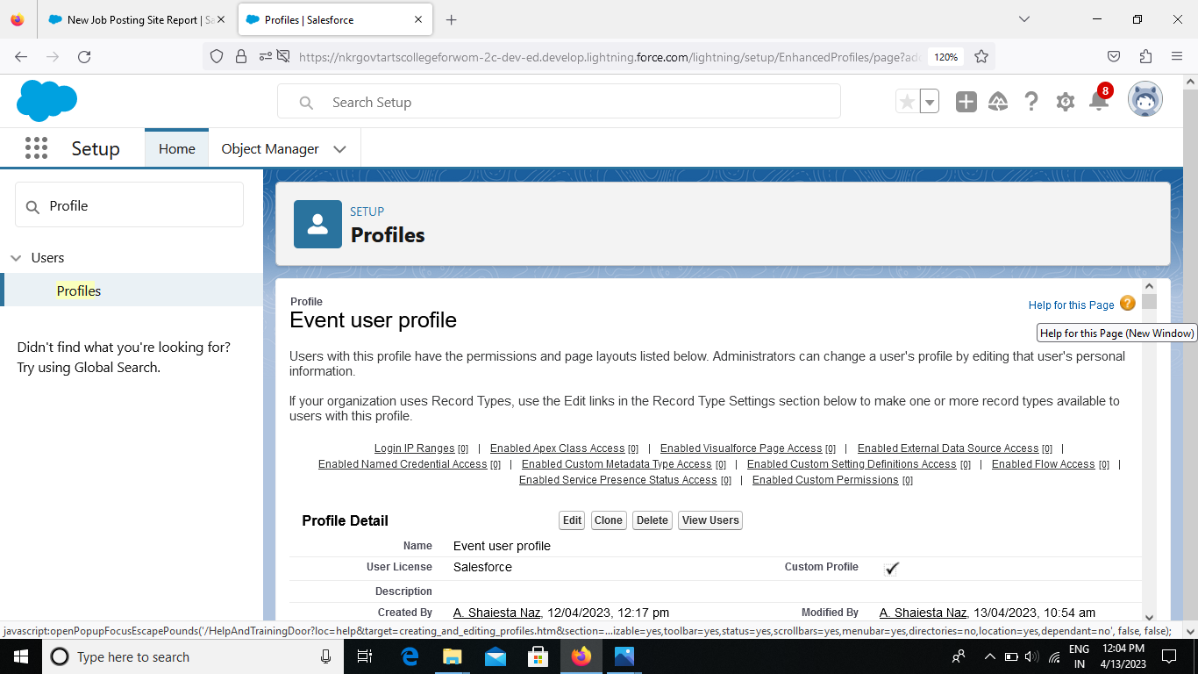

We created a profile with profile name “event user profile”.

Milestone-10

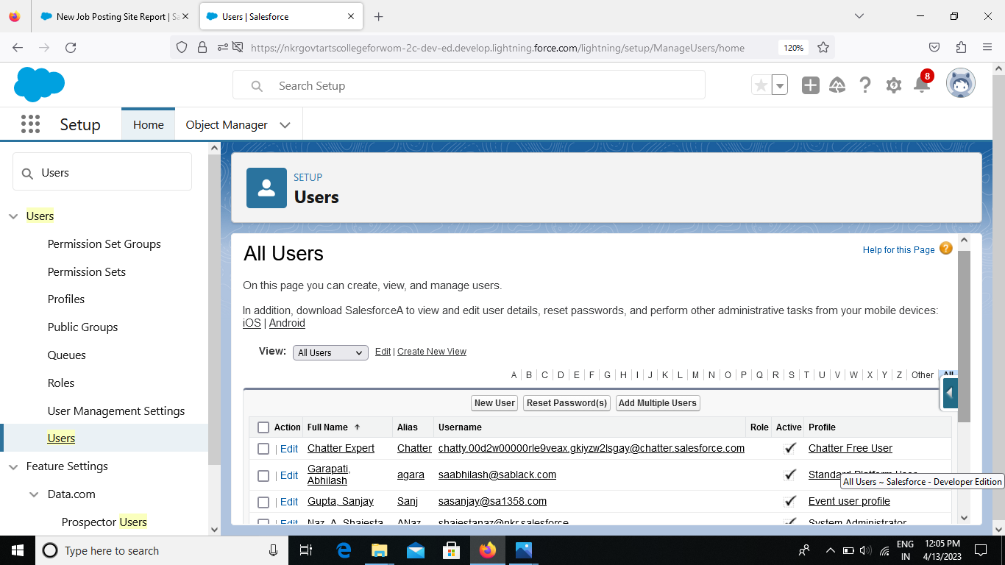

We created a users with the username “sanjay gupta” & ”abhilash garapati”.

Milestone-11

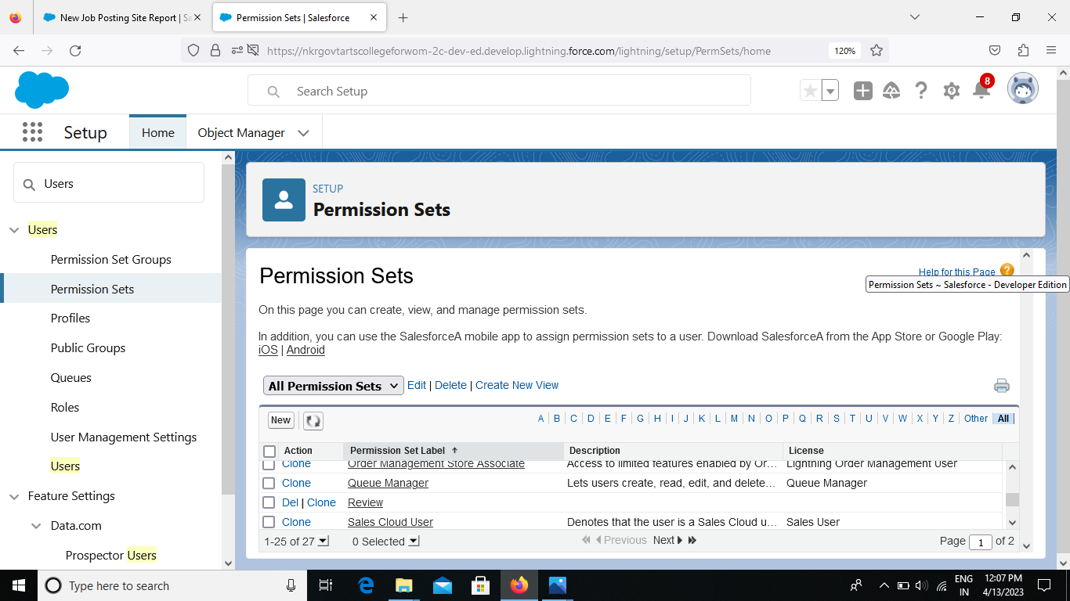

We created a permission set for “review object”.

Milestone-12

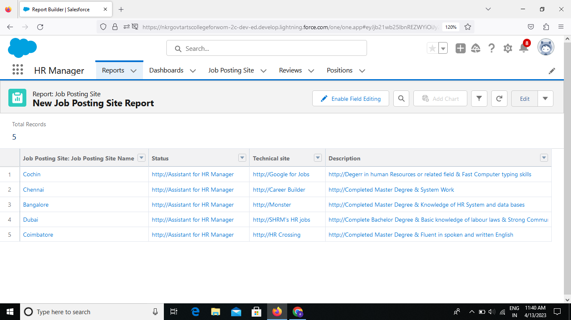

We created reports for “job posting object”.

4.TRAILHEAD PROFILE PUBLIC URL

Team leader – <https://trailblazer.me/id/travichandran8>

Team member 1 – <https://trailblazer.me/id/ushaiestanaza>

Team member 2 – <https://trailblazer.me/id/usitm>

Team member 3 – <https://trailblazer.me/id/ggopika3>

5.advantages and disadvantage

Advantages

1. Provides higher quality candidates
2. Ensures faster hiring
3. Helps hire applicants with specialist knowledge
4. Promote business growth and innovation

Disadvantages

1. Recruitment may stagnate the company’s culture
2. Increases training costs of the new applicants
3. Recruitment agencies have limited choices

6.applications

Recruiting assistants schedule the interviews and evaluations of the qualified applicants, endorsing them for final assessments with a department’s hiring managers. They also assist with the processing of recruitment for the the hired candidates and managing their onboarding procedures.

7. conclusion

Include all necessary skills, and include a list of desired skills that are not necessary but that would enhance the candidate’s chances if we fail to do this, we might end up with a low quality pool of candidates and wind up with limited choices to fill the open.

8.FUTURE SCOPE

The role of HR is continuously evolving and HR professionals can aim to learn about the technologies, trends and openational changes shaping the future of business. HR can be agile in adapting to those changes in order to effectively support employee development, retention and recruitment. The future of recurting will include Automation,strategic planning,and better integration with company objectives. Companies now need to focus intensely on recuiters skills to manage and execute recruitment in a future market.